

Group 3

Aashritha Veesamsetty

Ajinkya Shrikant Ambike

Kelly Hung

Shruti Mathur

Venkatasinjith Varmakalidindi

**CLUSTERING**

Using the Segmentation Analysis were able to categorize the existing customer base into 4 categories. The 4 categories were distinct from each other in their size and the total revenue that they were contributing to Wendy’s. Cluster 4 holds about 20% of the customer base contributing to about 50% of the revenue to Wendy’s. Wendy’s can concentrate on this class of people to reap more gains from them. Although this cluster isn’t the highest with respect to household income, they have been loyal customers to Wendy’s longer than the rest. Asserting the Pareto Principle in this scenario, Wendy’s can channel a higher amount of promotions to this segment, which can be recognized as a great effort by the company to reward their existing customers and bundle more products in their offerings to provoke them to buy more.

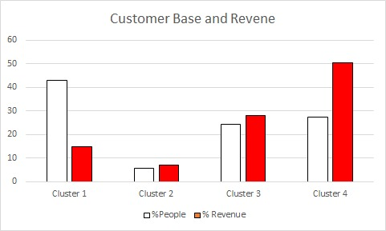 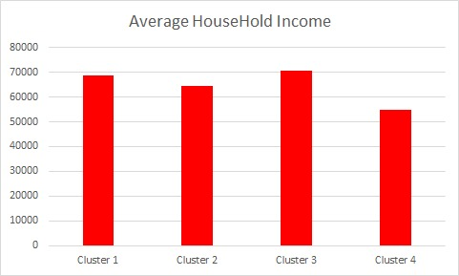

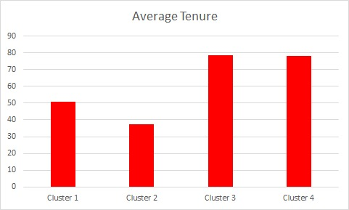

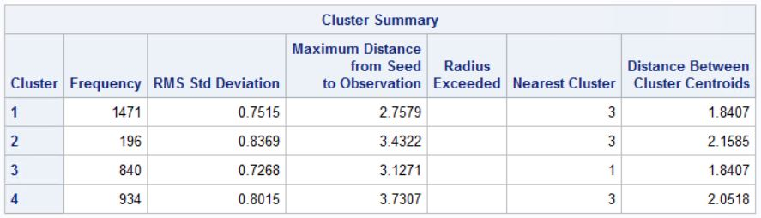

|  |  |
| --- | --- |
|  | Elasticity |
| Cluster 1 | 0.3754 |
| Cluster 2 | 0.9709 |
| Cluster 3 | 0.3329 |
| Cluster 4 | 0.7243 |

From the above graph in tandem with the Price Elasticity graph, we can say that,

* Cluster 2 and 4 are not very inelastic but just on the borderline. Prices for cluster 4 can be increased by a marginal percentage to gain more from their purchases and add more to the revenue. People of Cluster 4 prefer Meals with deals which also represent their behavior that they might start responding to a price hike if it will be increased sharply. So, more coupons and more discounts can be offered to this segment when they purchase multiple offerings.
* For Cluster 2, no price change is recommended as they’re close to reaching 1 which means that in the minds of the customers, the price paid corresponds to the value desired. A similar marketing strategy can be used for this cluster, where more deals are offered based on the quantity of offerings purchased.
* For cluster 3 and 1, as they are the least inelastic among the other 2 segments it indicates that these customers would not mind spending any price for an offering of Wendy’s. It is every marketer’s goal to convert relatively elastic customers to relatively inelastic and Wendy’s is doing well in this regard.
* For Cluster 1, who constitute 40% of the customer base but only offer less than 10% of the revenue, a very marginal amount of marketing efforts must be spent on them.
* For Cluster 3, which constitutes about 25% of the customer just like Cluster 4, we can capitalize on this segment when we have reached a threshold for Cluster 4. For instance, if the goal is to gain 80% of the revenue from Cluster 4, but if this is unattainable due to price elasticity, we can try to gain the difference in expected and current revenue goals from Cluster 4 to Cluster 3 by using heavy promotions to this segment.

**LOGISTIC REGRESSION (BINARY LOGIT)**

Using the available Wendy’s data, we used the Binary Logistic Model to understand the coupon usage behavior by the new customers of Wendy’s. Companies spend a large part of their income to reinvest in acquiring new customers or reward existing ones by offering discounts and special deals. In a similar fashion, Wendy’s uses welcome coupons to reward their new customers and this information has been recorded in the data set.

Using this model, we were able to regress the Welcome Coupon (REDEEM_WELCOME) against the average price spent (AVG_PRICE), tenure of the customer (TENURE), the marketing channel used (_DM, _EM, _SMS) and the location these customers belong to (DMA).

***What’s in this for Wendy’s?***

Using this model, we were able to conclude that, among the available marketing communication channels, sending an SMS to new customers converted into more coupon redemptions compared to results by Direct Mail and Emails. This could be because not everyone checks their mail boxes often which could trigger an impulse purchase. And with many companies flooding customer inboxes with coupons, it may be lost with the other promotions. Hence, Wendy’s should continue using the SMS strategy to reach out to new customers.

This is also supported by the signs of the coefficients of the 3 channels. The coefficient against SMS is, 0.28 which means there is 1.335 times chance that a coupon is redeemed when one SMS is delivered. As we are rejecting the null hypothesis based on the P value of these parameters, it reinforces that the channel used to reach out to customers is significantly supporting our statement that SMS works best.

The DMA parameter refers to the different locations that Wendy’s is operating in. The parameter coefficient is significant in this instance of 95% significance level. To understand the DMA categories better, we categorized the locations into groups.

Namely,

* DMA90
* DMA220
* DMA320
* DMA970

And by using the following chart, we conclude that, the maximum conversions were from DMA 220, followed by DMA970. An important learning from this exercise could be that, for DMA90 and DMA320, Wendy’s can trigger promotional messages closer to these areas to drive in more traffic into stores located in those locations. The current campaign that led to these results were successful for DMA220 and DMA970 assuming that the intended targets were achieved.

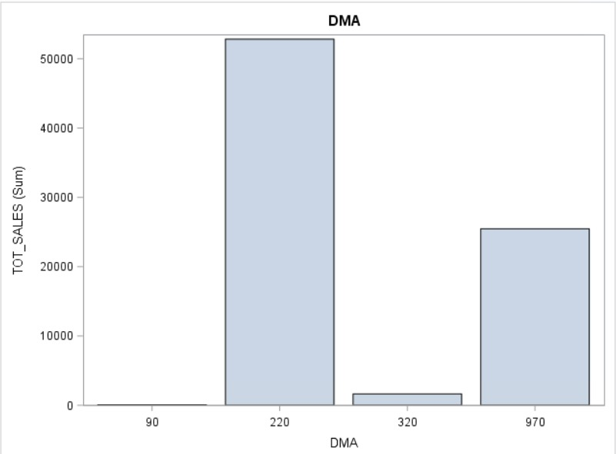

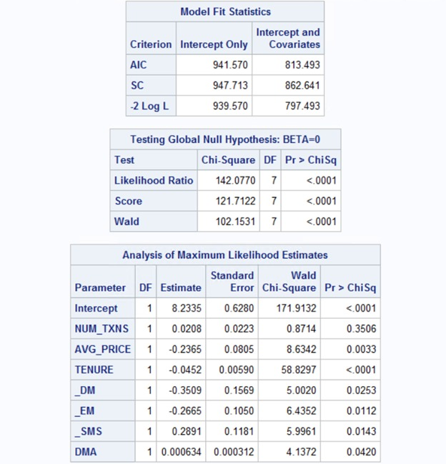

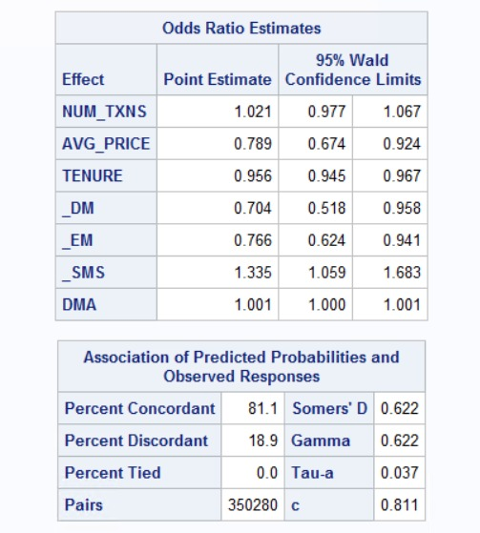

***AVERAGE PRICE***

The average price variable has a negative coefficient which means that, for every coupon used the average price paid by the customer is reduced by 77%. This is in line with the thought that, a lower price is paid when a coupon is redeemed on a purchase.

***TENURE***

The duration of the customer is significant for the coupon usage. This is also in line with the thought that this coupon was only for new customers, which means it is important that the customer is new and has signed up for rewards and promotions from Wendy’s. The negative coefficient indicates the same.

With an increase in the duration of the customer, the odds of them redeeming the coupon is reduced by 0.04 times.

**OLS REGRESSION**

***Interpretations***

* For every additional quantity purchased of Hamburger, total sales per customer will increase by $4.3. Since Wendy’s major revenue earned is through sales of hamburgers, we can say that customers buy more of Hamburgers than any other product.
* For every additional purchase made during evening time (DYPT_PCT_EVEN), the total sales increases by $1.61. We can conclude here that people come at Wendy’s mostly during evening time and less during lunch time or late night. Therefore, to engage customer retention during morning or lunch time, Wendy’s can offer coupons to customers that come during dinner, related to meals offered during the day so that even the sales for those product increases.

